

OBJECT ORIENTED PROGRAMMING
CCS20704, DCS20504, CCS23803

Received Date : 3 September 2026

Submission Due Date: 23 October 2026
Lecturer : Dr. Jamal Abdullahi
Weightage : 15%
Semester : SEPTEMBER 2026

Instruction to students:
- This is a GROUP assignment.
- Complete this cover sheet and attach it to your assignment (first page).

Student declaration:
I declare that:
- This assignment is my/our own work.
- I/we understand what is meant by plagiarism.
- My lecturer has the right to deduct my marks in case of:
- Late submission
- Any plagiarism found in my assignment.
NAME:Rakhimbayev Akhmet  MATRICS NO: 012026090532 | NAME: Azree Muhaimin Haziq bin Ahmad Zuki  MATRICS NO: 012025091910 | NAME: Sahrvin A/L Sekar  MATRICS NO: 012025021265
 |  | 

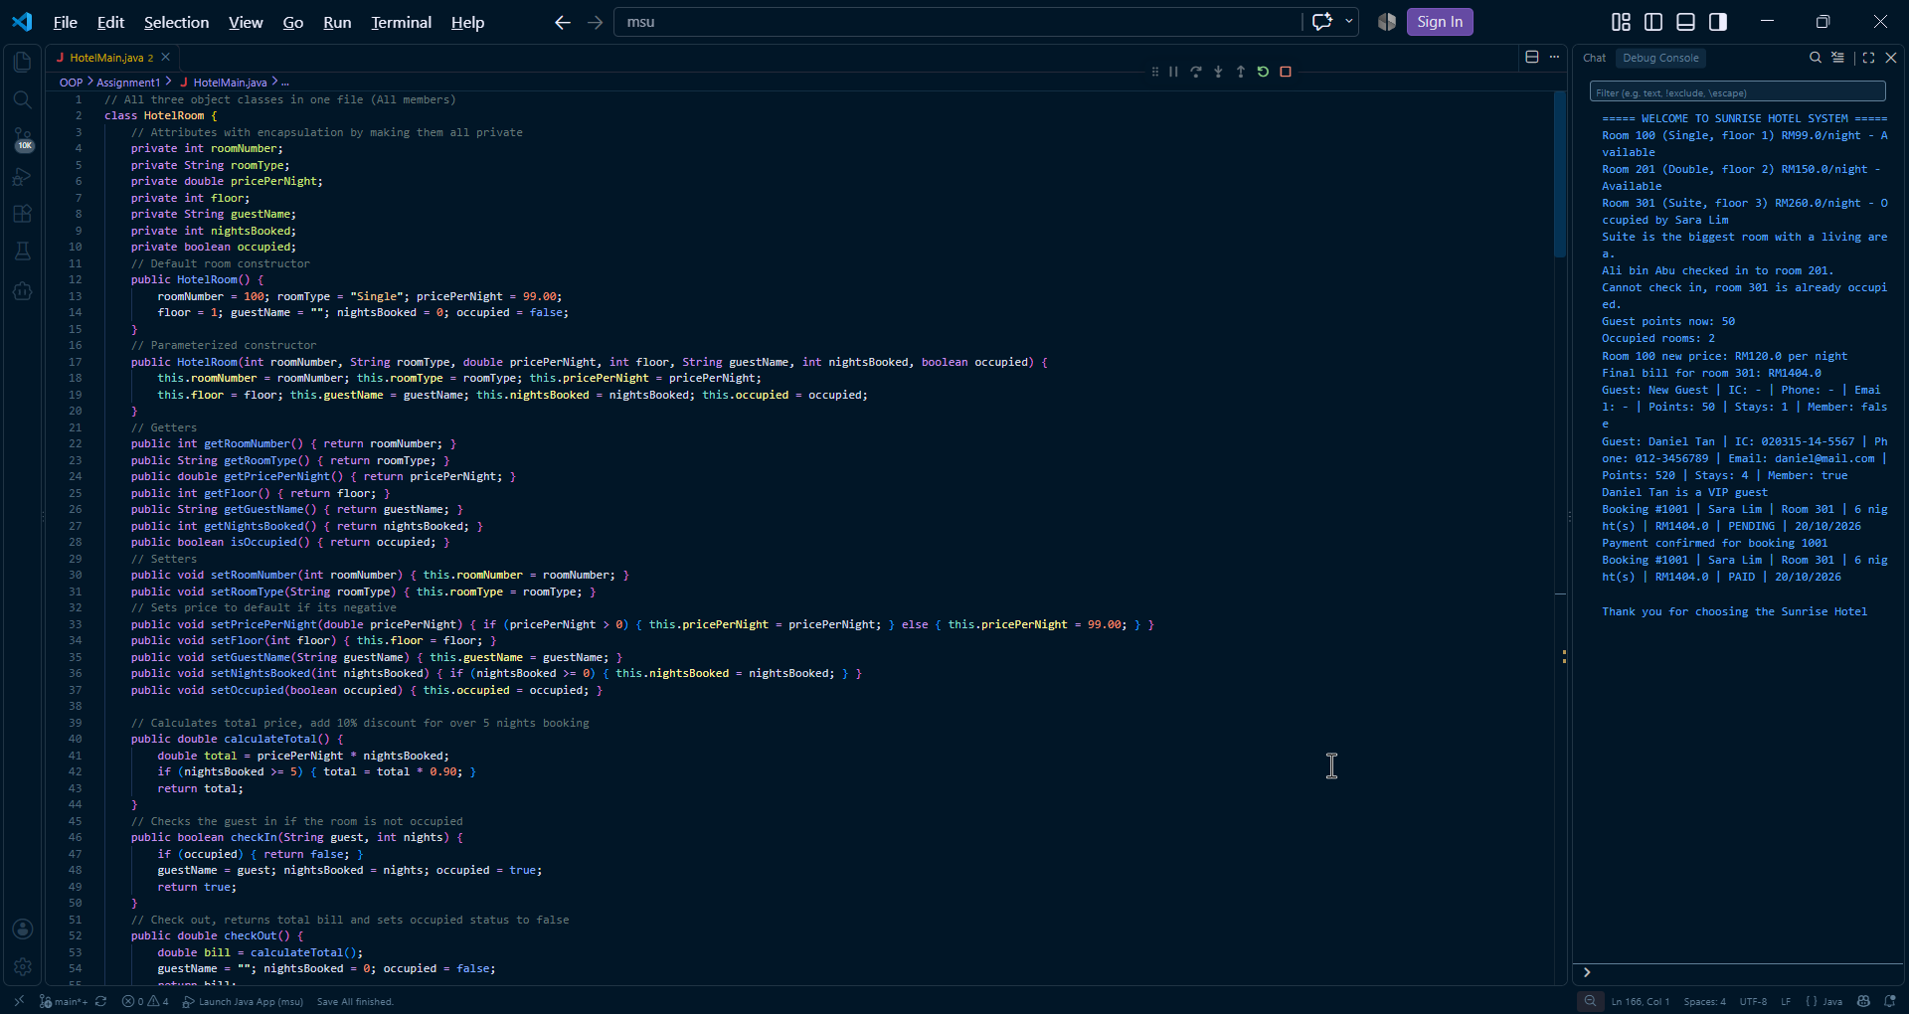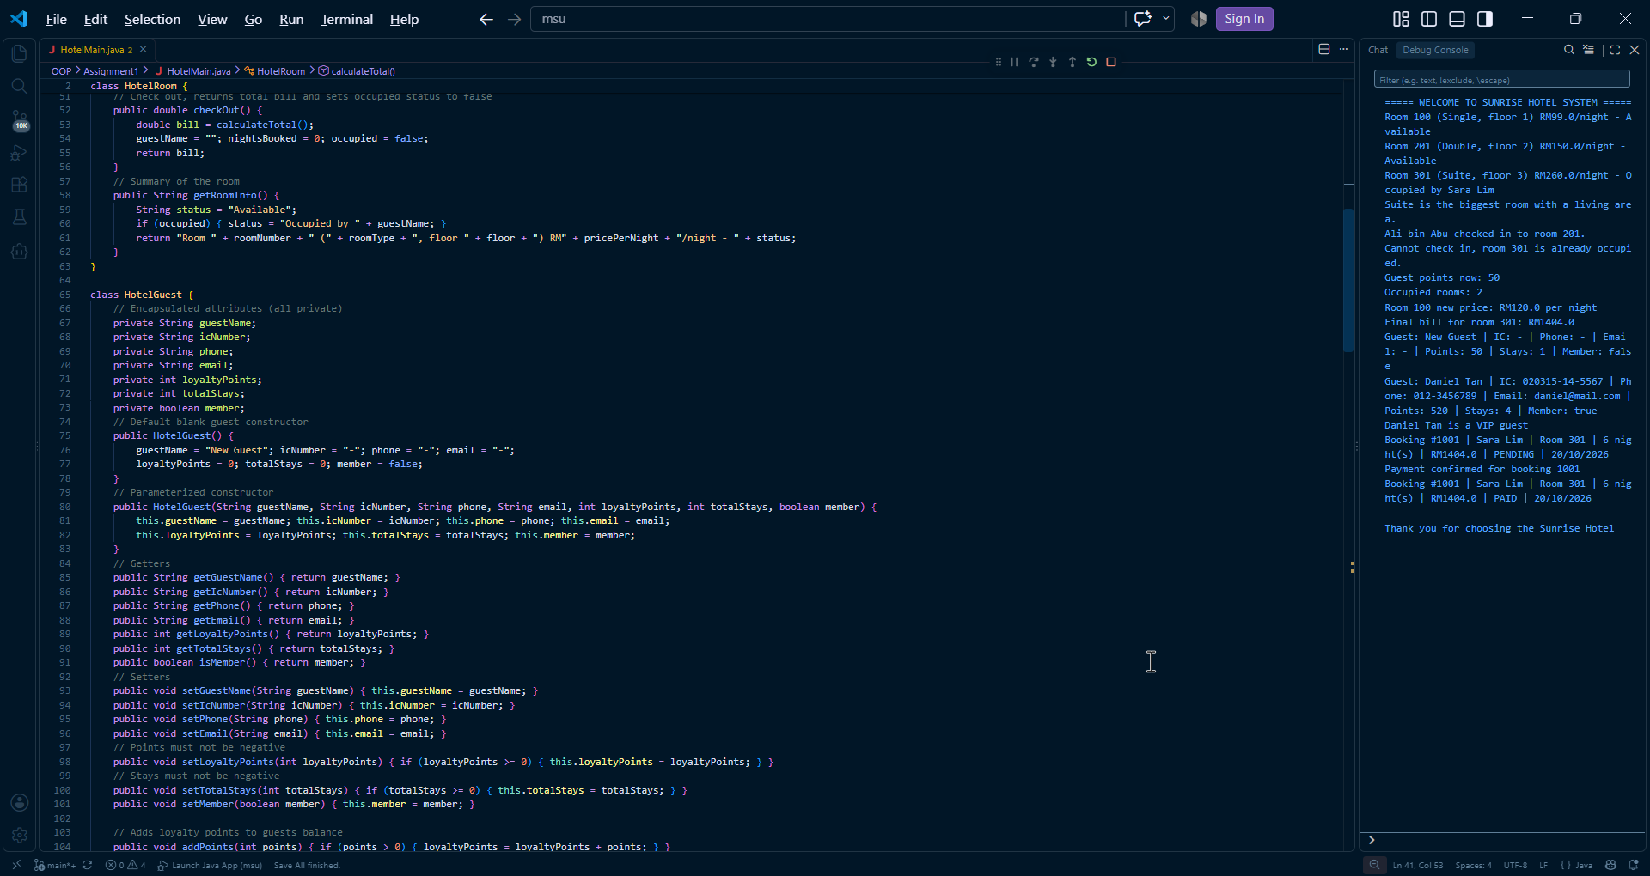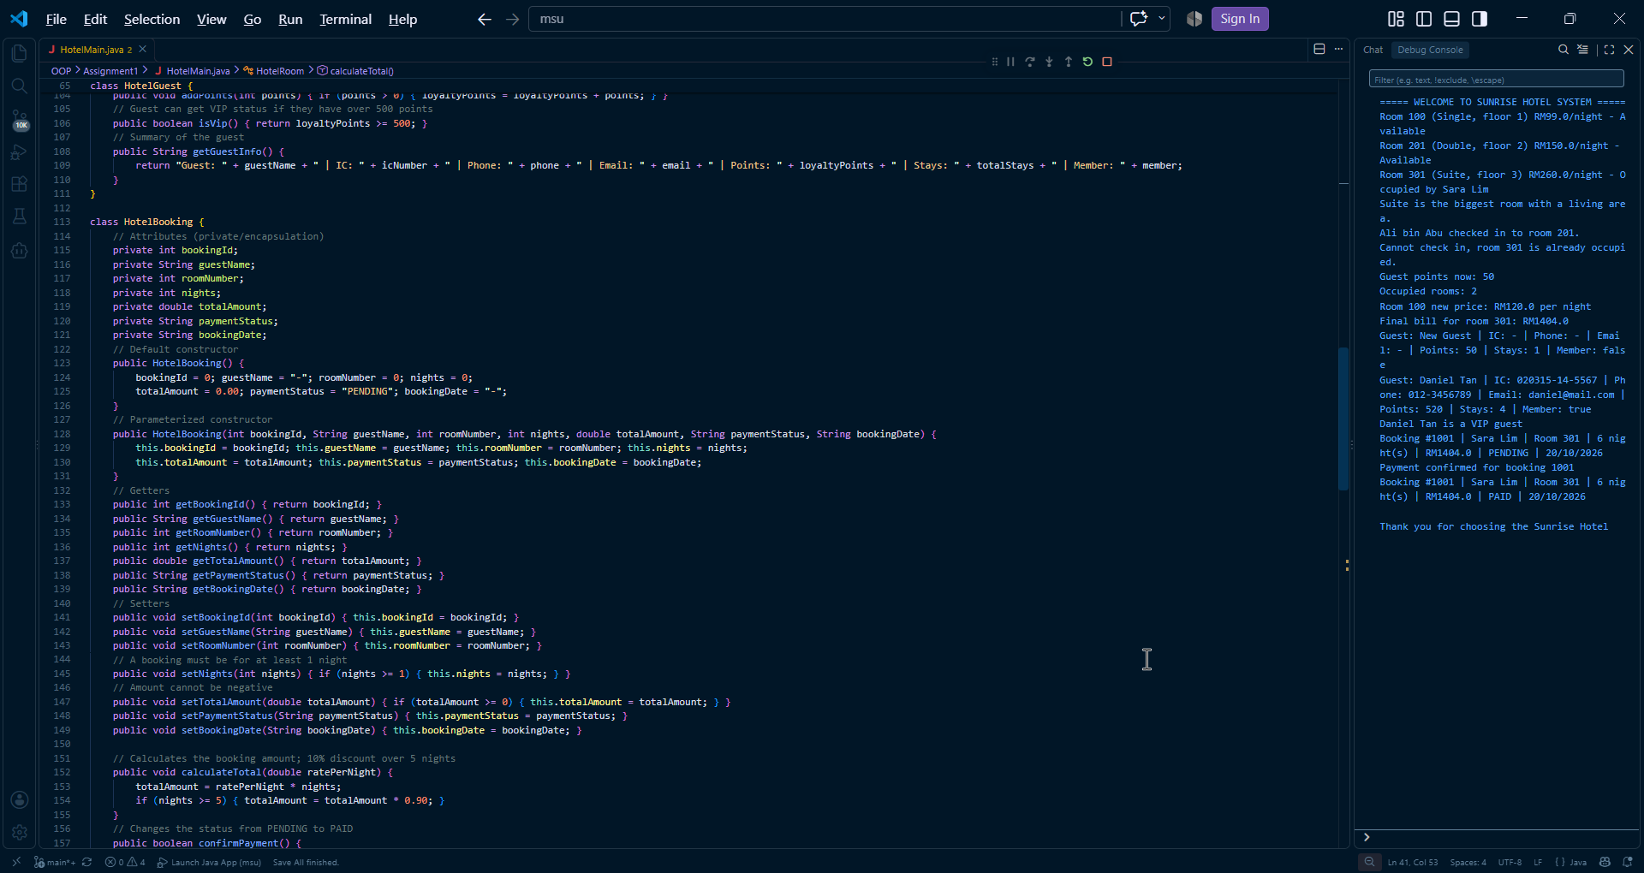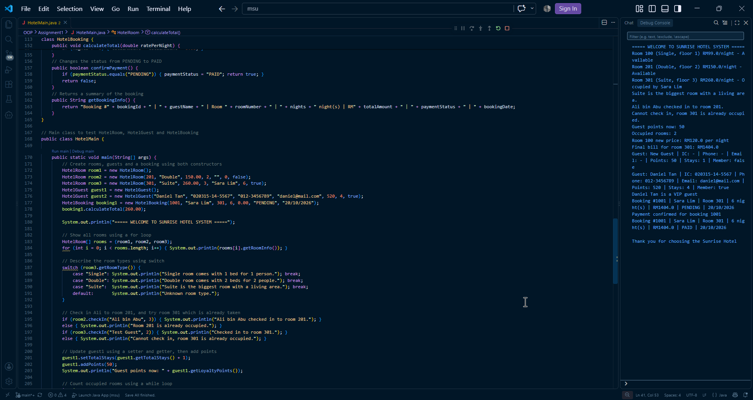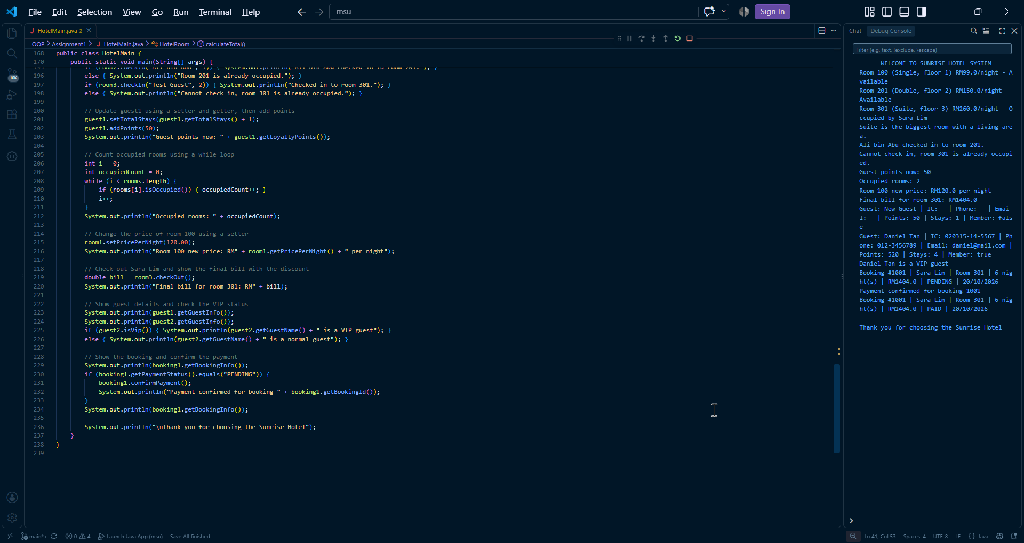

RUBRIC for Assignment One
CLO1 – Describe the concepts of object oriented programming. (C5, PLO1)
COMPONENT | CRITERIA / WEIGHTAGE (%) | LEVELS of ACHIEVEMENTS/ DESCRIPTORS
COMPONENT | CRITERIA / WEIGHTAGE (%) | Excellent (4) | Good (3) | Average (2) | Needs Improvement (1) | Not Attempted (0) | Marks
CONTENT (20%) | Object Design Understanding (5%) | Clear and accurate explanation of class, attributes, methods, and constructors using correct OOP terms | Mostly correct explanation with minor gaps | Basic explanation but lacks clarity | Limited or incorrect explanation | No explanation
CONTENT (20%) | Encapsulation Concept (5%) | Strong understanding; correct use of private attributes and getters/setters | Good understanding with minor issues | Basic understanding but inconsistent | Weak understanding | No attempt
CONTENT (20%) | OOP Principles Explanation (5%) | Clearly explains class, object, and methods with examples | Mostly clear explanation | Basic explanation | Poor explanation | Not explained
CONTENT (20%) | Presentation Knowledge & Understanding (5%) | Confident explanation using OOP terms; answers questions clearly | Good understanding | Basic explanation | Weak understanding | No participation
PROCESS (40%) | Class Implementation (10%) | Fully meets requirements (≥7 attributes, 2 constructors, getters/setters, ≥5 methods) | Mostly complete with minor issues | Partially complete | Incomplete | Not attempted
PROCESS (40%) | Encapsulation Implementation (10%) | Majority attributes private; proper getters/setters used | Mostly correct | Some inconsistencies | Poor implementation | Not implemented
PROCESS (40%) | Control Structures in Main Class (10%) | Effective use of if/switch and loops integrated with object | Correct with minor issues | Basic use | Minimal/incorrect use | Not used
PROCESS (40%) | Code Logic & Interaction (10%) + (Presentation) | Clear logic; meaningful interaction using methods | Mostly logical | Basic logic | Weak logic | Not functional
PRODUCT (40%) | Functionality & Output (5%) | Program runs correctly with accurate output | Mostly correct output | Basic output with issues | Incorrect output | Not working
PRODUCT (40%) | Creativity & Object Design (5%) | Highly creative, real-world, advanced methods | Creative and relevant | Basic design | Generic design | Not appropriate
PRODUCT (40%) | Code Readability & Comments (5%) | Clean, well-organized, fully commented code | Mostly readable | Limited comments | Poor readability | No comments
PRODUCT (40%) | Report Quality & Documentation (10%) | Well-structured report; clear explanation; proper formatting | Mostly organized | Acceptable | Poor documentation | Not submitted
PRODUCT (40%) | Presentation & product Knowledge (15%) | Confident explanation using OOP terms; answers questions clearly | Good understanding | Basic explanation | Weak understanding | No participation
 | TOTAL

